**AUREUS: AURORA RENEWABLE ENERGY & UV SEQUESTRATION**

**C-Helix**

**Proposed by: Dashrath Prajapat**

**Constructed by: Dashrath Prajapat**

**Atul Patel**

**OBJECTIVE:** -The measure objective of this technology is to use the UV light from sunlight and decrease the harm of UV light by converting it into usable energy form. Uses technology synthesized from upcycled crop waste to absorb stray UV light from sunlight and convert it to clean renewable electricity. To fulfill the losses of crop spoils of farmers, creating a better environment for people outdoors and advantage in UV sequestration.

**ABSTRACT: -**The AUREUS system is an evolution for walls/windows, and uses technology synthesized from upcycled crop waste to absorb stray UV light from sunlight and convert it to clean renewable electricity. the composition uses for the AUREUS system comprising photo-luminescent elements that absorb UV radiation and emit longer wavelength non ultraviolet radiation. Photo-luminescent elements are dispersed on or in a material that may be a transparent film. IT champions the issues of UV sequestration, better access to solar energy for climate change mitigation and supporting the local agriculture industry hit by calamities by upcycling crops that would otherwise be considered wastes thus, mitigating farmer loss and provides better environment.

**EXECUTION: -**

* Astralis solar walls & Borealis solar window: -

Both AUREUS devices use the same technology derived from the phenomena that governs the beautiful Northern and Southern lights. High energy particles are absorbed by luminescent particles and degraded to low energy state as visible light. Similar type of luminescent particle (derivable from certain fruits and vegetables) was suspended in a resin substrate and is used as the core technology on both devices. When hit by UV light, the particles absorb and re-emit visible light along the edges due to internal reflectance. PV cells are placed along the edges to capture the visible light emitted. The captured visible light are then converted to DC electricity. Regulating circuits will process the voltage output to allow battery charging, storage, or direct utilization of electricity.

****Solar Farms are built horizontally and never vertically, until now. Since AUREUS captures UV, it can produce electricity even when not facing the sun. Buildings clad on all sides with AUREUS become vertical solar farms.

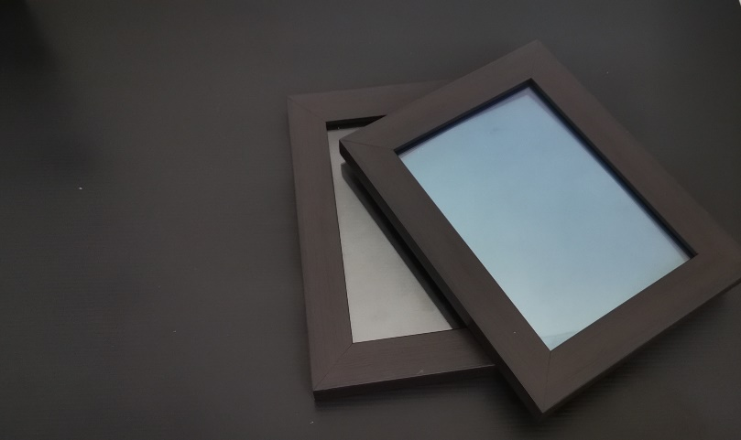****

****Miniaturized Borealis solar window can power a small DC motor.

****Montreal Convention Centre: conversion to AUREUS tech will unlock additional 18 kW power asset.

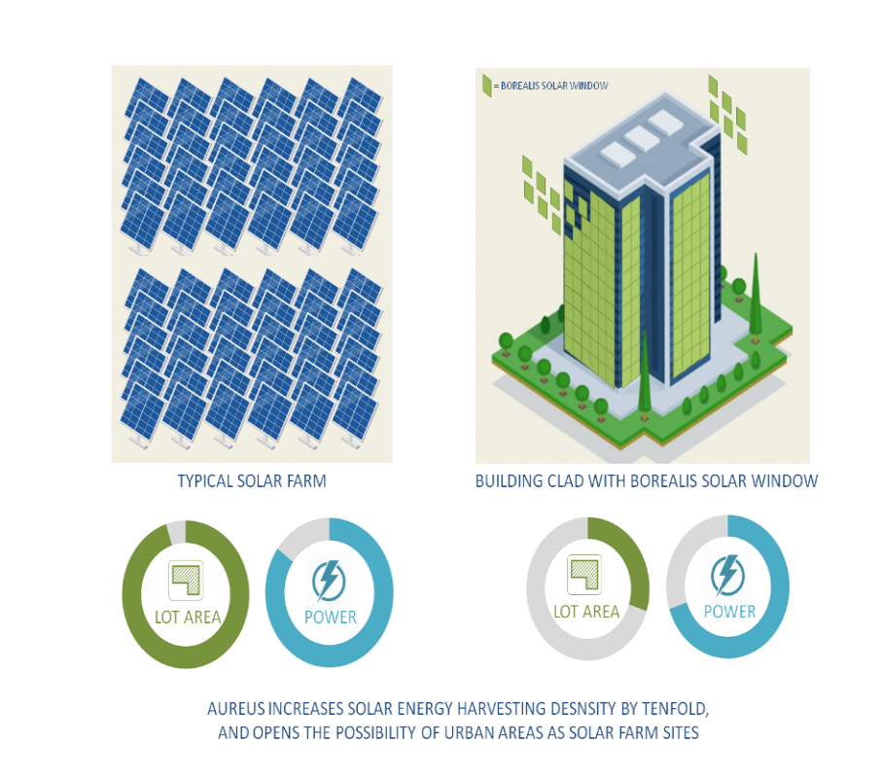

****AUREUS increases solar energy harvesting density by tenfold and opens the possibility of vertical solar farm sites in urban areas.

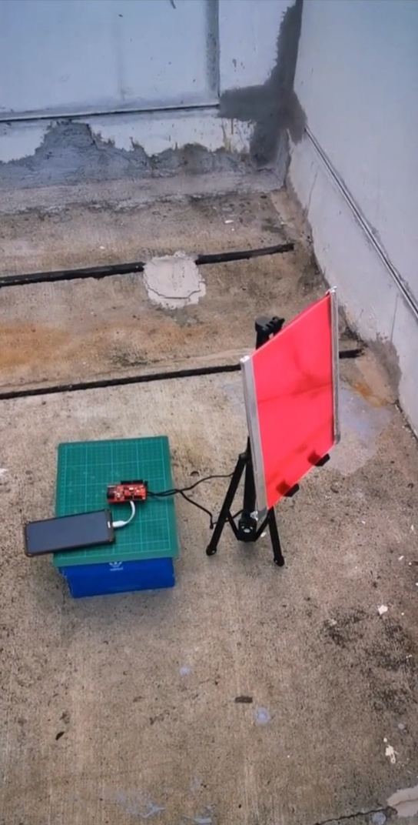

****Resin with luminescent dye extracted from tomato gave the substrate a reddish hue.

****Proof of testing: Performance of the substrate with extracted dye from Tomato (Lycopersicum Esculentum)

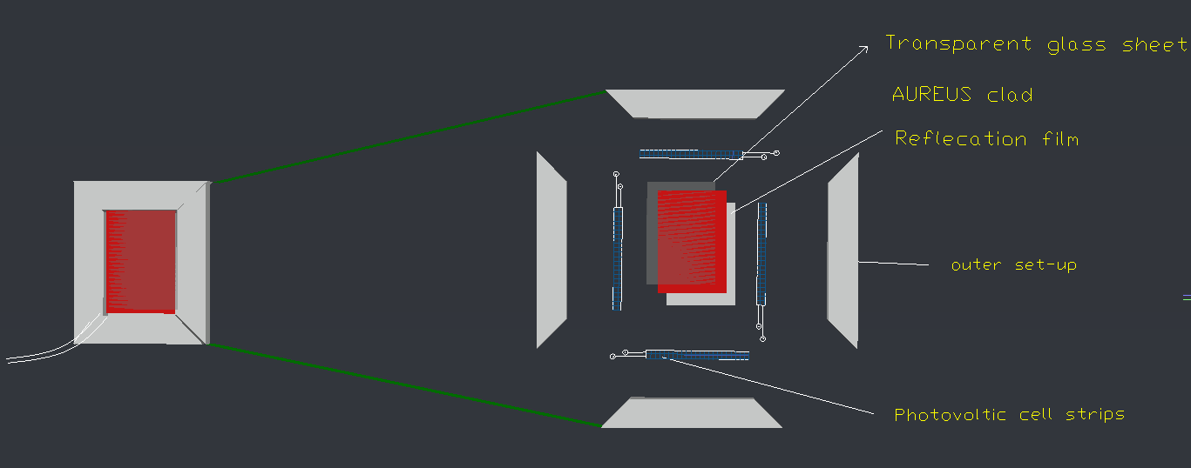

**&&Composition of substances used in the formation of mixture of AUREUS CLAD:-

Resin A= 55-65% Resin B = 30-35%

Dye = 7 - 9% (Lycopersicum Esculentum)

****This the prototype of this project.

AUREUS cladding can be applied to windows and walls, will increase additional power asset.

***\*\*\*\*Internal working of the Aureus clad.***

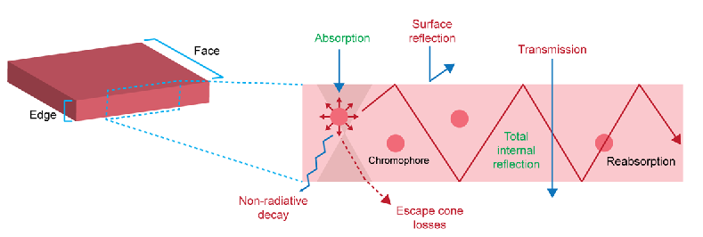

**Experimental data:-**

|  |  |
| --- | --- |
| UV light intensity exposure to AUREUS clad(Watt/square feet) | current(micro ampere) |
| 0 | 0 |
| 20 | 89 |
| 22 | 98.1 |
| 24 | 107 |
| 26 | 115.9 |
| 28 | 124.9 |
| 30 | 133.8 |
| 32 | 142.7 |

**Existing technology:-**

Solar panel is used normally for photo-voltaic module. A PV module is an assembly of photo-voltaic cells mounted in a framework for installation. In Photo-voltaic cells semiconductor is used which convert mostly visible range of sunlight into electrical energy and generate direct current electricity but it is unable to converts other ranges of radiation like :-ultra violet radiation etc. And by using this AUREUS devices with solar technology we can also convert UV light to visible range radiation to electrical energy.

**AUREUS TECH: -** The AUREUS system is an evolution for walls/windows, in AUREUS tech we form a substrate comprising photoluminescent elements that absorb UV radiation . In certain aspects the photoluminescent elements are dispersed on or in a material form transparent film which is favourable for windows by cost and for environment.

**Learning Outcomes: -**

* Learning more about software.
* This project having wide opportunity in electrical energy field and economically profitable**.**

**Social benefits: -**

* By using upcycled crop waste as UV light absorbent is economically beneficial for farmers and local agriculture industry.
* Use of AUREUS tech will unlock additional power asset. (PV solar panels are only absorb visible range of sunlight, but by using it UV convert to visible range and used for production of electrical energy)
* AUREUS can function even when not directly facing the sun, it can rely on UV scattering through clouds and by UV light bouncing along walls, pavements, other buildings. This will enable the construction of a Vertical Solar Farm even with a small lot area.
* Advantage in UV sequestration and creating a better environment for people outdoors.
* It is very low-cost tech cause of upcycled crop waste use as absorbent.

****Advantage in UV sequestration for people outdoors:

UV rays is absorbed and redirected to the edges of the fluorescent polymer plate as visible light as principle of fluorescence. The visible light emitted is then converted by photovoltaic modules into electricity.

*This minimalizes the reflect of UV rays unto streets pedestrians.

*electricity can be stored for later use.

AUREUS Project Theoretical & Experimental Calculation

Intensity of total energy from sun= 1360 W/m2

29% Reflects to space.

Total Energy 23% atmosphere

48% reaching to earth.

Total energy reaching to earth surface = 1360 × 48 ÷ 100 = 653.28 W/m2

Approximate 4% of sun energy intensity is UV light intensity = 653.28 × 4 ÷ 100

= 26.1312 W/m2

energy absorbed per m2 = 26.1312 W/m2

:: If we take the AUREUS clad (substrate made by tomato dye Lycopersicum Esculentum) efficiency 100% than –

energy absorbed per m2 = 26.1312 W/m2

Solar panel (Photoelectric cell strips) total efficiency= 18%

(So, it converts 18% of light to electricity)

˳˚˳ Power= Intensity × Area

Power for 1m2 = 26.1312 × 1= 26.1312 watt

Electrical Energy= Power × Time

= 26.1312 × 1= 26.1312 watthour

(For 1 m2 ) per day electrical energy = 26.1312 × 24

= 627.1488watthour

: Due to approximate efficiency of household solar panel is 18%: -

Remain electrical energy= 627.1488 × 18 ÷100

= 112.8938 watthour

Power for 3 × 2 feet2 sheet= 112.8938×6÷10.7584

= 62.9613 W/feet2

# Conversion to mahof power: -

Power of watt hour= electrical energy × voltage ÷ 1000 (˳˚˳voltage= 5 , electrical energy in mah)

Electrical energy =62.9613 × 1000 ÷ 5

|  |
| --- |
| Electrical energy = 12,592.2635 mah |

**12,592.2635 mah amount of electrical energy waste per 3*2 feet2 area .**

According to experimental data we know AUREUS clad having 80% absorbing efficiency approximate.

Aureus clad (tomato dye) absorbed 80% UV light energy absorbed per m2 = 26.1312 *80/100

=20.9049 W/m2

Solar (Photoelectric cell strips) total efficiency= 18%

˳˚˳ Power= Intensity × Area

Power for 1m2 = 20.9049 × 1= 20.9049 watt

Electrical Energy= Power × Time

= 20.9049 × 24= 501.7176 watthour

(For 1m2) per day electrical energy= 501.7176 watthour

Solar (Photoelectric cell strips) total efficiency= 18%

Due to 18% efficiency of solar panel. (So, it converts 18% of light to electricity)

Remain electrical energy= 501.7176 ×18 ÷ 100

=90.309168 watthour

Power for 3 × 2 feet2 sheet= 110.3778 × 6 ÷ 10.7584

= 50.3657 W/feet2

# Conversion of mah of power:-

Power of watt hour= mah ×voltage÷1000 (˳˚˳voltage= 5)

Electrical energy =50.3657×1000÷5

|  |
| --- |
| Electrical energy = 10,073.1522mah |

**So, we get 10,073.1522 mah electrical energy**.

|  |  |  |  |  |
| --- | --- | --- | --- | --- |
| S. No. | COMPONENTS | QUANTITY | SPECIFICATIONS | COST (RS.) |
| 1 | Resins A&B | 250gm per | Transparent Epoxy Resins | 500 |
| 2 | Photovoltaic cell strips | 4 |  | 1000 |
| 3 | Voltage regulator | 1 | Microcontroller | 1050 |
| 4 | DC motor | 1 | 3v | 200 |
| 5 | Transparent silicone rubber sheet | 2 |  | 800 |
|  |  |  | Total cost = | 3550 |

**BUDGETARY REQUIREMENTS**

|  |  |  |  |  |
| --- | --- | --- | --- | --- |
| S. No. | COMPONENTS | QUANTITY | SPECIFICATIONS | COST (RS.) |
| 1 | AutoCAD | 1 | design | 0 |
| 2 | Blender | 1 | animation | 0 |

conclusion:-

Conversion to AUREUS tech will unlock additional power asset and the advantage in power density against solar farms. In urban areas there is the wide opportunity for the skyscraper to use AUREUS tech on walls and windows to asset more electrical energy. By using AUREUS substrate that having luminescent particles absorb UV light radiation and degraded to visible light radiation. The AUREUS system is an evolution for walls/windows known Borealis solar window and Astralis solar wall.

Future Scope**:-**

Additional research will be done on extracting needed luminescent particles to allow 100% (from the current 80%) sourcing of dyes from fruits and vegetables instead of chemical ones. Currently, among the 5 colors used (Red, Orange, Yellow, Green, and Blue) a stable alternative to the blue dye has not been successfully made yet. Success in this area will bring sustainability to a full circle. Manufacturing: Currently AUREUS is standing at a 30 panel/mo. production. Additional funding can allow the creation of a team and facility that can increase current capacity.

Future: Advances in forming for chassis in solar powered transport.